Employability Skills Activity

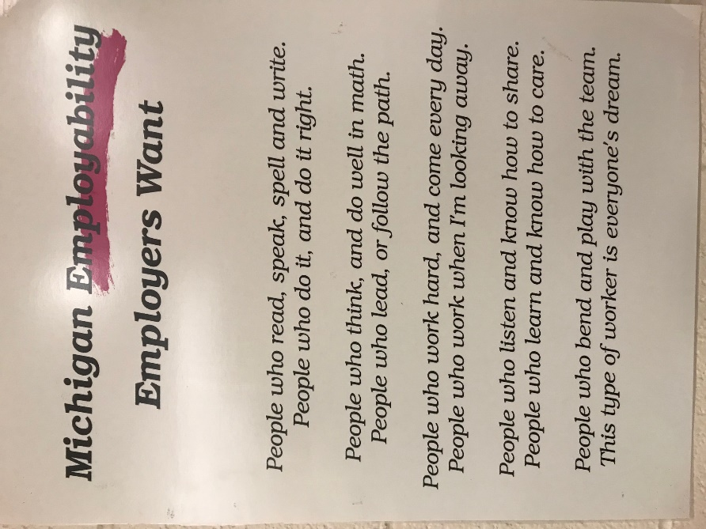
- Please read the poster pictured here.

- Think about what you are doing well in this list after asking yourself questions like:
  - Do I pay attention to grammar, spelling, and punctuation when I communicate?
  - Am I good with basic math skills?
  - Am I self-sufficient when it comes to doing my work?
  - Do others consider me a hard-worker?
  - Am I a distraction when others are working?
  - Do I work well with all people of different ages, abilities, ethnicity, and with different interests than me?
  - Am I dependable?
  - Can I keep my attention on my work until it is finished?
  - Do I have good attendance 99% of the time?
  - Am I always on time and ready to work?
  - You can draw other questions from this poster.

- Consider the areas where you need to improve.

- Then create a document about you. In one paragraph explain your strengths giving examples of things you’ve done. In another paragraph, give your weaknesses and write a plan for improvement.

- This should be a Word document. Start with “No Spacing” style and Times New Roman font sized at 12. Change the vertical spacing to 2 so that all lines will be double-spaced.

- Title the document with your name centered at the top of the page.

- Include an introduction and a conclusion.

