Distributive Property
The sum of two or more numbers times a third number is equal to the sum of each added times the third number.
** The Distributive property does not work for division or subtraction!

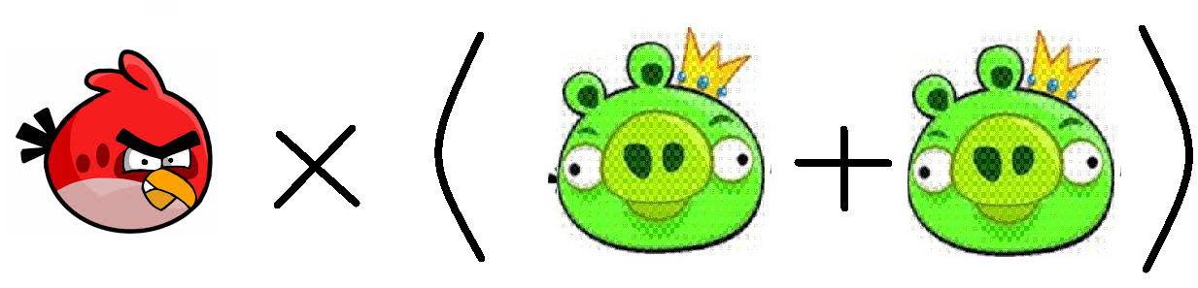
₍₎ ₊₍)

Commutative Property of Multiplication
The "Commutative Laws" say we can swap numbers over and still get the same answer.
** The commutative property can work for addition but NOT division!

3 x 2 2 x 3

Associative Property of Multiplication
The "Associative Laws" say that it doesn't matter how we group the numbers (i.e. which we calculate first) ..
** The associative property works for addition, but NOT subtraction!

Name: __________________
Place the letter of the property below each mathematic example!
Associative: A
Distributive: D
Commutative: C

- (3x9)x7=(9x7)x3 6. 9(9+9)= (9x9)+(9x9)
____ ____
- 1(2x4)= (1x2) +(1x4) 7. 32x2= 2x32
____ ____
- 4x11= 11x4 8. 1(2+3)= (1x2)+(1x3)
____ ____
- \ (2x3)x3= 2x(3x3) 9. (7x1)=(7x1)
____ ____
- 5678 x1234 = 1234x5678 10. 2x(6x3)=(2x6)x3
____ ____

