Modeling Observations of the Universe Lab
Staple Balloon used for experiment here
Staple rubber band used for experiment here
Name____________________
Hr.___________
Engel’s earth science on a shoe string©

Objective: According to the Big Bang Theory, almost all galaxies are moving outward from all other galaxies. You can demonstrate the principles of this expansion with a simple model.
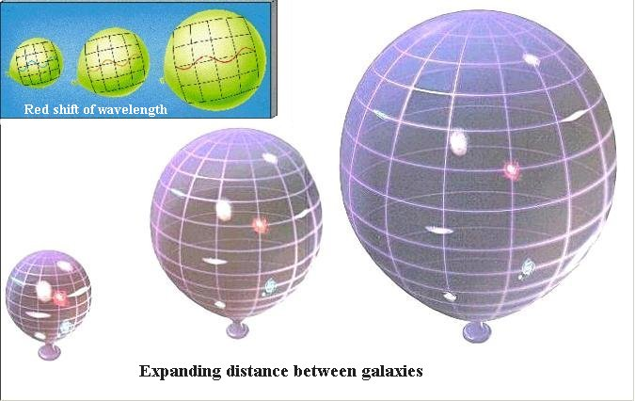
Materials: Balloon, pen, string, ruler

Procedure.
- Mark a pair of dots 0.5 cm apart across the middle of the uninflated balloon. Label them A and B. Mark a third dot 5.0 cm away from B. Label this dot C.
- Blow into the balloon for 3 seconds. Record your elapsed time. Pinch the end of the balloon between your fingers to keep it inflated, but do not tie the neck.
- Use the string and ruler to measure the distance between A and B and between B and C. DO NOT LET THE AIR OUT OF THE BALLOON!
- Calculate how fast the galaxies (dots) moved apart from each other,
to calculate this, use the following formula:
After inflation 1distance between A - B (step 3)
  - -- Original distance between A - B

Divide this number by 3 (the number of seconds you blew into the balloon)
This is your rate of change - record it in the data table.

- With the balloon still inflated from Step 2, blow into the balloon for an additional 3 seconds.
- Measure and calculate the rate of change in distance between A and B. and between C and B. To calculate the rate, use the distance measures in Step 3 as the 'original' distance.

 | Distance between points  A - B | Distance between points  C - B | Rate of change with galaxies A - B | Rate of change with galaxies C - B
Uninflated |  |  | --------- | ---------
After inflation 1
After inflation 2

- In this lab what do the following items represent:
  - The balloon _____________________________________________________________
  - The dots (a, b, c) _________________________________________________________
  - The inflation of the balloon/spreading out of the dots _____________________________
___________________________________________________________________________
- Did the distance between A and B or between C and B show the greatest rate of change? ______________________________________________________________________________________________________________________________________________________________

- Suppose dots C and A represent other galaxies and dot B represents our Milky Way. How does the distance between the galaxies relate to the rate at which they are moving apart? _______________________________________________________________________________ _______________________________________________________________________________

- Explain the Big Bang Theory? _______________________________________________________________________________ _______________________________________________________________________________

- Explain how this lab modeled the movement of our universe and the Big Bang Theory?
____________________________________________________________________________________________________________________________________________________________________
CMB radiation of the Universe Lab
Engel’s earth science on a shoe string©
Materials: Rubber band pen stars ruler scissors

Procedure:
- Make one cut in you rubber band so that it makes a flat piece.
- Every two cm draw a dot on the top edge of the rubber band and along the bottom draw a dot 1 cm from each n the top edge. Draw a regular wave pattern, connecting the top dots to the bottom dots, from one end to the other end.
- Place 4 stars randomly on the rubber band. Number each star starting with number one.
- Now stretch the rubber band and describe:
a) What happens to the distance between the stars?
b) What happens to the wavelength?
- Pretend you are on a spaceship hovering near star 1, describe what you see happening to the Universe. What would you see from your spaceship hovering Star 2? Star 3? Star 4?
- Now let’s look at this using measurement. Complete the following data table before you stretch the rubber band and after:
Before stretching After stretching
Length of rubber band
Number of waves
Average wavelength
Distance between stars 1-2
Distance between stars 2-3
Distance between stars 3-4

Discussion:
- Since the rubber band represents space, and the stars represent stars or galaxies (things made up of matter) explain what happens to matter as space expands.
- What happens to the total number of waves as space expands?

- As space expands what happens to the wavelength?

- How does this relate to the Red Shift?

- If you could continue to stretch the rubber band (and it did not break) what would happen to the wavelength?

- How are wavelength and temperature related?

- Shortly after the Big Bang occurred, about 14 billion years ago, the Universe was very hot, about 3000 K, why then today, is the CMB at about 2.7 K ?

- How does the temperature of the CMB support the theory of the Big Bang?

- What other evidence is there that supports the Big Bang Theory?

- Why do scientists say that there is no center of the Universe or conversely everywhere is the center? (Hint: think about procedure 5.)

Further Analysis:
Using the CMB’s peak wavelength of about 10⁻³ m and its present temperature, calculate its peak wavelength when it formed at the surface of last scattering. What type of electromagnetic (EM) wave was that at that time? What type of EM wave is it today?

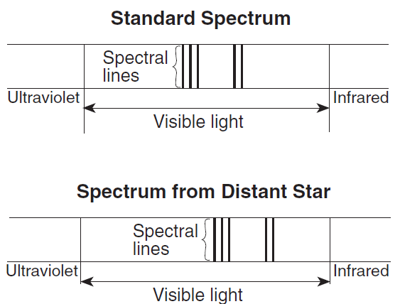
The diagram below shows a standard spectrum compared to a spectrum produced from a distant star.

Which conclusion can be made by comparing the standard spectrum to the spectrum produced from this distant star?

(1) The star’s spectral lines have shifted toward the ultraviolet end of the spectrum and the star is moving toward Earth.

(2) The star’s spectral lines have shifted toward the ultraviolet end of the spectrum and the star is moving away from Earth.

(3) The star’s spectral lines have shifted toward the infrared end of the spectrum and the star is moving toward Earth.

(4) The star’s spectral lines have shifted toward the infrared end of the spectrum and the star
is moving away from Earth.

The diagram below represents a swinging Foucault pendulum.
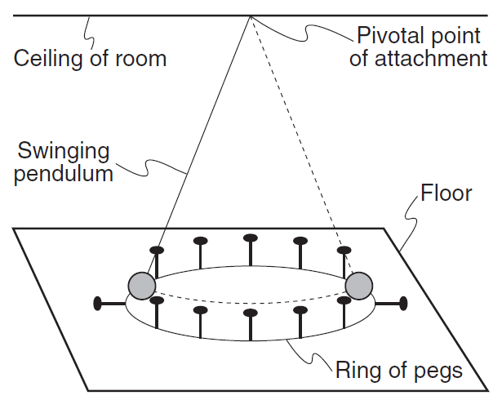
This pendulum will show an apparent change in the direction of its swing due to Earth’s
(1) curved surface (3) rotation
(2) tilted axis (4) revolution

The diagram below shows the spectral lines for an element.

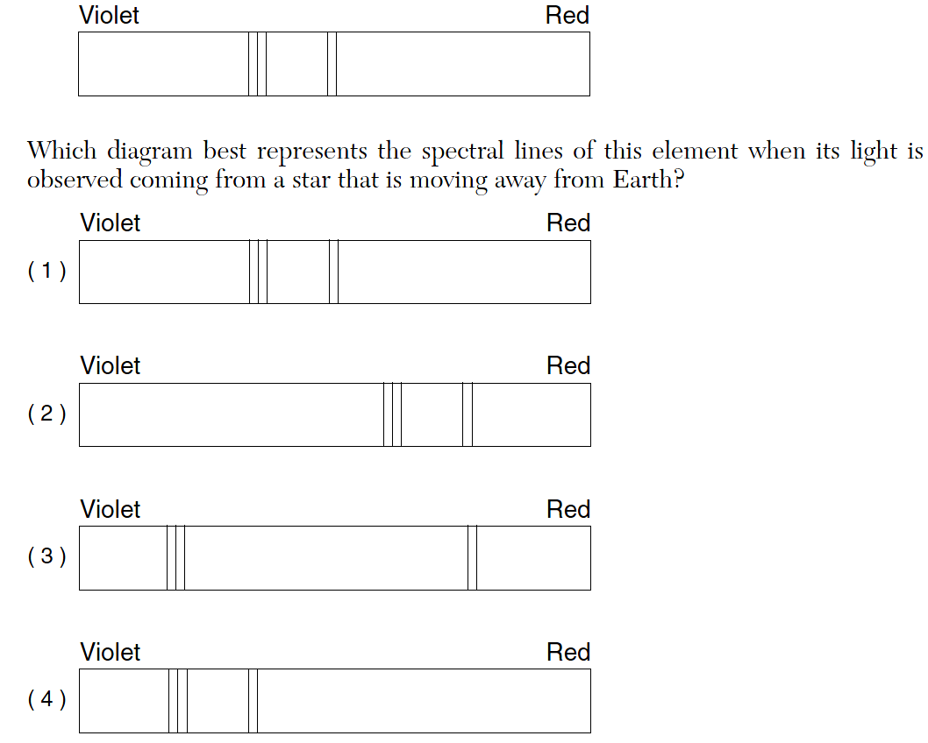

The diagram below illustrates three stages of a current theory of the formation of the universe.

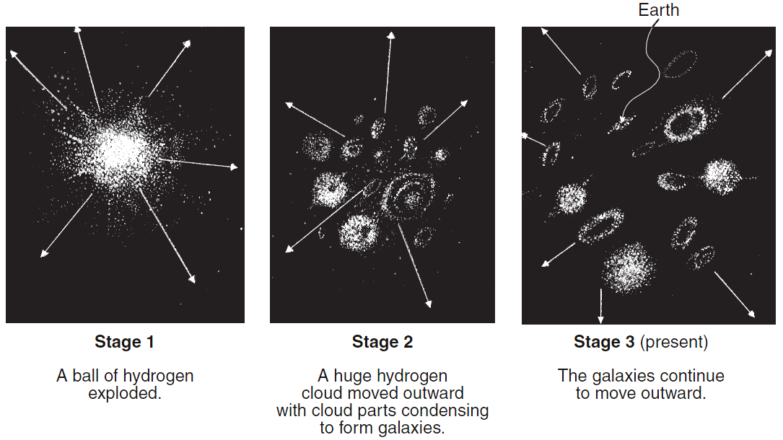

A major piece of scientific evidence supporting this theory is the fact that wavelengths
of light from galaxies moving away from Earth in stage 3 are observed to be
(1) shorter than normal (a red shift) (3) longer than normal (a red shift)
(2) shorter than normal (a blue shift) (4) longer than normal (a blue shift)

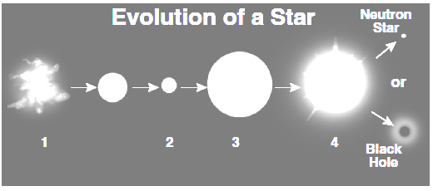

Which of the above evolutionary stages of a massive star is called a supernova?
F 1
G 2
H 3
J 4
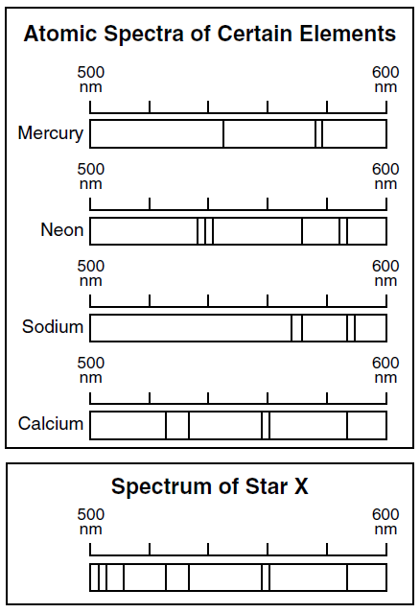

Which of these elements does this star contain?
A Mercury
B Calcium _
C Sodium
D Neon

From Rubber Bands to Big Bangs

The Universe has been expanding for 13.72 billion years from a smaller, hotter, denser form to its present cooler, larger, and less dense form. You might ask, “What is expanding, and how do we know that?” The Cosmic Microwave Background Radiation (CMB) is scientific evidence that shows space itself is expanding. As space expands it cools and the original CMB waves have been stretched with this expansion of space. Although space has more than the two dimensions we will focus on with our rubber bands in this lab, we will gain a feel for the expansion of space.

Evidence for the Big Bang:
Red shift CMBR
Nueclieosysnthisis
Observations of galaxies and stars
(Earlier stars have less heavy elements)
CMBR fluctuations

CMBR Polarization

