Doppler Radar Lab 14
Engel Earth Science Savers™ Simonized Name_____________________ Hour____ Date_______

Radar, short for radio detection and ranging, is a system that sends out radio beams and then picks up any reflected energy from aircraft, ships, or other objects to determine their location and speed.
Radar is a highly focused beam of very short radio waves, which travel out from their source in a straight line, at a constant velocity. Radar travels at the speed of light 186,000 miles per second.
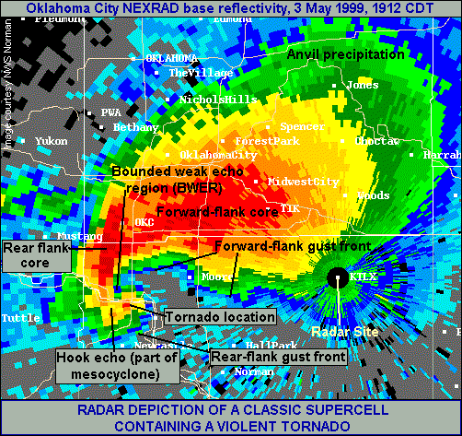
A classical "hook_echo"
Intensity of a tornado is measured on the Fujita scale). The intensity can be derived directly with high resolution Doppler radar . The scale ranges from F0 for the weakest to F5 for the most powerful known tornadoes. No F6 tornado has yet been detected.

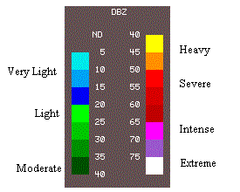
How Doppler Radar Sees Into the Cloud
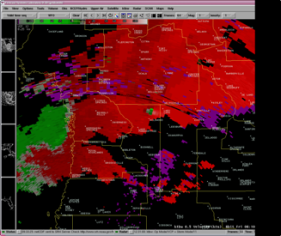
Radar detects objects by bouncing an electromagnetic signal off of it and measuring the time it takes for the signal to return. The National Weather Service considers the presence of a hook echo as enough to issuing a tornado warning.
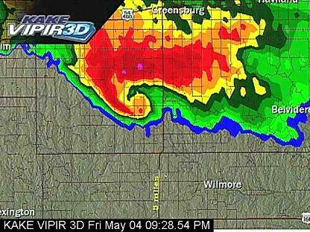
Doppler radar detects objects moving toward the radar and objects moving away from the radar. The return signal is different for objects moving away from the radar and objects moving toward the radar.
Doppler radar calculates both the speed and direction of motion of a severe storm. A developing tornado can be detected forming above the earth before it reaches the ground. (On velocity radar, Dark red colors next to dark green in a hook area near the southern part of the storm are a tip off!)

Surround Sound uses the Doppler Effect
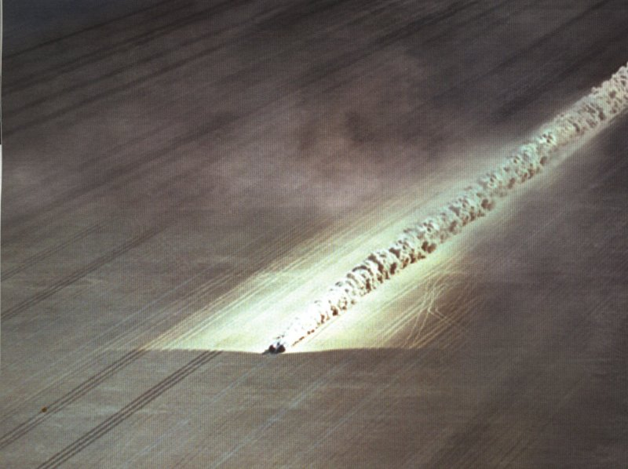

Surround Sound adds more audio channels so sound comes from three or more directions. Each speaker is on its own electrical circuit. This means the computer can send sound to each speaker at a different time to give the illusion of a sound source moving past you. This shift in frequency is called the Doppler shift. Open the following sound file and
Car breaking sound barrier.
listen to the Doppler shift.

Open the following link and listen to the “Doppler Effect”
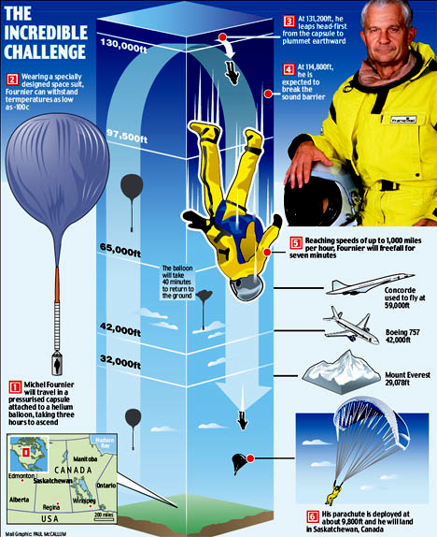
http://www.kettering.edu/~drussell/Demos/doppler/carhorn.wav

Open the following link and answer
http://www.nationalgeographic.com/forcesofnature/interactive/index.html
1. Tab 2 One in a thousand thunderstorms becomes a [x].

2. One in five or six [x] creates a tornado.

3. On tab 2 hit next - A [x] is a rotating updraft.

4. On tab 3 - The average tornado is [x] meters wide and stays on the grounds for about 30 miles.

5. On tab 5 - Tornadoes need cool dry air from the north, warm moist air from the south, falling pressure and [x] winds.

Open the following link and answer the questions that follow.
http://www.srh.noaa.gov/ffc/?n=hotseat
Click “Yes!Bring it on!” and try the first site that is easy.

6. How many severe thunderstorm warnings were to be issued [x]

7. How many tornado warnings? [x]

Question: Can you use known data to determine an unknown distance?

Investigation:
Step 1-Obtain one super ball and record the ball size, color or description. Record description here-____________________________ This may be a two day lab and you will need the same equipment on day two as a control variable. Also obtain a meter stick or meter tape. Assign one person the task of being equipment manager for this lab.
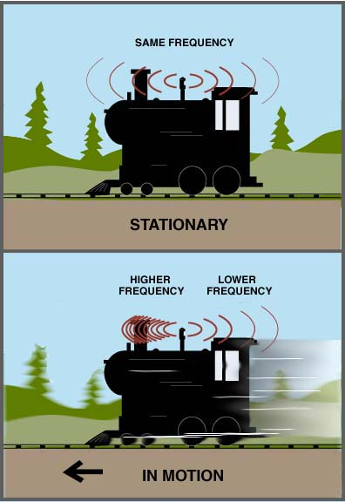
Step 2-Carefully set the ramp up so that it is at 40-degree angle and place the ramp at a distance of 25 cm from the wall. Draw a faint pencil line across the floor using the front of the ramp.
Step 3-Place the front edge of the ramp on the launch line. Do this for every launch!
Step 4-Place the ball at the top of the ramp. (Be sure to do this for every launch.)
Step 5- Note the time of the release of the super ball or golf ball.
Step 6-Record the elapsed time to the nearest fraction of a second. The time should represent the time that it takes the ball to roll down the ramp, bounce off the wall, and return to the starting line. Disregard rolls that fail to return and cross the line.
Step 7- Make five releases from each distance and recording the data table below, the time that it takes for the ball to go from the launcher to the wall, and back to the launch line in the data table below.
Step 8- Move the launching ramp to a distance: 25 cm and repeat this for step 1-8. Do this for the following distances of 50 cm, 75 cm, 100 cm. 125 cm, 150 cm, 175 cm, and 200 cm.
Step 9- Throw out the largest and smallest values, and then average the three remaining values. (To average numbers, add the three values a together, then divide by three.)
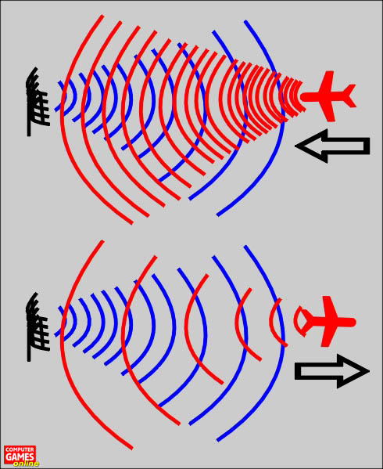

Step 10- Plot the average times on the graph found on the back of this sheet. Label the X-axis “Time” in seconds, and the Y-axis “distance” in cm.

Stop 11-Use your data to determine the unknown distances to the nearest cm.

Step 12- When you have your data recorded; enter them into Blackboard for each of the “real” values of your unknown distances.

Distance(cm) | TIME (sec)
 | Trial 1 | Trial 2 | Trial 3 | Trial 4 | Trial 5 | Total | Average
25
50
75
100
125
150
175
200

Make a line graph of the average times to distances below. Refer to Step 10 for labeling the axes.

How to become a weather spotter!
http://www.crh.noaa.gov/mkx/spotter/2005BasicSpotterPresentation.htm
http://broadband.ciconline.org/windward/default.aspx
http://www.fema.gov/kids/games1.htm
http://www.shambles.net/pages/learning/primary/Weather/
movie http://www.thefutureschannel.com/dockets/realworld/predicting_weather/

How to become a weather spotter!
http://www.crh.noaa.gov/mkx/spotter/2005BasicSpotterPresentation.htm
http://broadband.ciconline.org/windward/default.aspx
http://www.fema.gov/kids/games1.htm
http://www.shambles.net/pages/learning/primary/Weather/
movie http://www.thefutureschannel.com/dockets/realworld/predicting_weather/

