Name_______________________________________
Hour______________________________

Genes through Geological time periods 2015
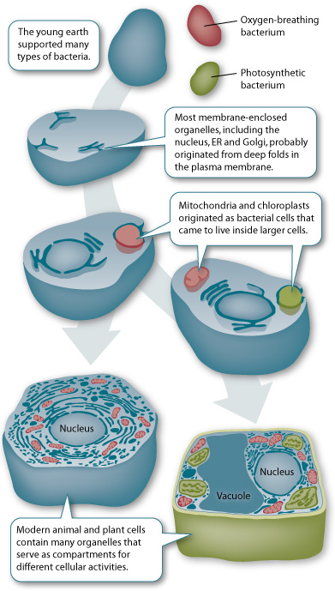
Cell theory: Open the following link and correctly answer the questions below;
http://learn.genetics.utah.edu/content/begin/cells/organelles/
Putting it all together!- Read the captions in the picture to the right.
First came _________ breathing bacterium, then _______________ breathing bacterium, Mitochondria and Chloroplasts originated as bacteria that came to live in _________ cells.
Modern plant and animal cells contain organelles that are compartments for different cellular ____________
MIND BLOWING VIRUTAL FLIGHTS THROUGH CELLS!
Click links below!
http://multimedia.mcb.harvard.edu/

http://www.xvivo.net/xvivo-takes-harvard-university-on-a-3d-journey/

http://www.wartgames.com/themes/science/cells.html
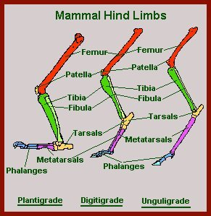

Geological time periods
Geologists have organized the history of the Earth into a timescale on which large chunks of time are called periods and smaller ones called epochs. Each period is separated by a major geological or paleontological event, such as the mass extinction of the dinosaurs which occurred at the boundary between the Cretaceous period and the Paleocene epoch. Open “Change”, Click “Deep Time” http://www.pbs.org/wgbh/evolution/change/deeptime/index.html
List an event that happened in the Hadean epoch _________________ (Roll your mouse over the different shapes on the timeline under the three main ideas, Geology, Transformation and Extinction ) IF you get REALLY stuck, click on the picture ad it will take you to another site,… but NOT recommended. (Deep Time is easier!)
19. List an event that happened in the Archaean epoch _______________________________
- 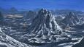Archean era3.8 billion–2.5 billion years ago

20. List an event that happened in the Proterozoic epoch _____________________________

21. List an event that happened in the Cambrian epoch ______________________________
- 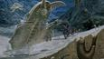Cambrian period545 million–495 million years ago

22. List an event that happened in the Ordovician epoch _____________________________
- 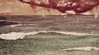Ordovician period495 million–443 million years ago

23. List an event that happened in the Silurian epoch ________________________________
- 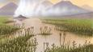Silurian period443 million–417 million years ago

24. List an event that happened in the Devonian epoch ______________________________
- 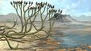Devonian period417 million–354 million years ago

25. List an event that happened in the Carboniferous epoch ___________________________
- 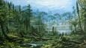Carboniferous period354 million–290 million years ago

26. List an event that happened in the Permian epoch ________________________________
- 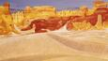Permian period290 million–248 million years ago

27. List an event that happened in the Triassic epoch ________________________________
- 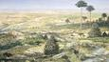Triassic period248 million–205 million years ago

28. List an event that happened in the Jurassic epoch ________________________________
- 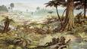Jurassic period205 million–142 million years ago

29. List an event that happened in the Cretaceous epoch _____________________________
- 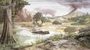Cretaceous period142 million–65 million years ago

30. List an event that happened in the Paleocene epoch ______________________________
- 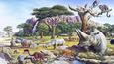Palaeocene epoch65 million–54.8 million years ago

31. List an event that happened in the Eocene epoch ________________________________
- 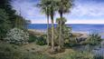Eocene epoch54.8 million–33.7 million years ago

32. List an event that happened in the Oligocene epoch ______________________________
- 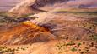Oligocene epoch33.7 million–23.8 million years ago

33. List an event that happened in the Miocene epoch _______________________________
- 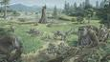Miocene epoch23.8 million–5.3 million years ago

34. List an event that happened in the Pliocene epoch _______________________________
- 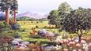Pliocene epoch5.3 million–2.6 million years ago

35. List an event that happened in the Pleistocene epoch _____________________________
- 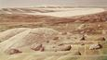Pleistocene epoch2.6 million–11.7 thousand years ago

36. List an event that happened in the Holocene epoch _______________________________
- 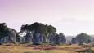Holocene epoch11.7 thousand years ago–present day

http://www.bbc.co.uk/nature/life/Homo
http://www.bbc.co.uk/nature/history_of_the_earth#extinction_events

Big Five mass extinction events
Although the Cretaceous-Tertiary (or K-T) extinction event is the most well-known because it wiped out the dinosaurs, a series of other mass extinction events has occurred throughout the history of the Earth, some even more devastating than K-T. Mass extinctions are periods in Earth's history when abnormally large numbers of species die out simultaneously or within a limited time frame. The most severe occurred at the end of the Permian period when 96% of all species perished. This along with K-T are two of the Big Five mass extinctions, each of which wiped out at least half of all species. Many smaller scale mass extinctions have occurred, indeed the disappearance of many animals and plants at the hands of man in prehistoric, historic and modern times will eventually show up in the fossil record as mass extinctions. Discover more about Earth's major extinction events below.
- 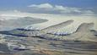Ordovician-Silurian mass extinction443 million years ago
- 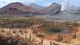Late Devonian mass extinction359 million years ago
- 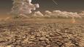Permian mass extinction248 million years ago
- 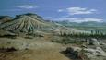Triassic-Jurassic mass extinction200 million years ago
- 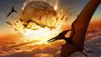Cretaceous-Tertiary mass extinction65 million years ago

Mass extinction theories
Asteroid impacts, climate change, volcanoes - there have been many theories about the causes of mass extinctions. In some cases, such as the Cretaceous mass extinction event, more than one such factor was involved in the global catastrophe.
- 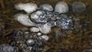Catastrophic methane release
- 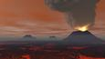Flood basalt eruptions
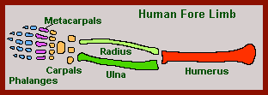
- 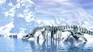Climate change
- 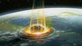Impact events

Go to: http://www.nature.ca/genome/04/041/041_e.cfm
Play “Copy Cat”.
1. Do the offspring always look like the clone? _______
Click on “Fact or Fake”.
2. The word clone comes from a Greek word that means ________________.
3. Dolly the sheep was ____________ the first clone.
4. Dolly the sheep aged ______________________.
5. Cloning can only bring ____________ skin or tissues animals back to life.
6. Scientist have ________________ cloned a person.
7. Cloning has been able to create ___________________________.
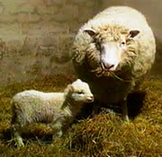
Play “Pass the Genes”.
The object is to give “Melvin” the correct “look”
8. To create dimples Melvin needs a _______________ and a ___________________.

Play “The Mighty Mutation Maker”.
9. What are the codons created by your name?__________________________________

Play “GMO”. Treat the sunburned corn.
10. The genes are coated with what element to make them dense enough to shoot into the corn? _____________
Play “Race the cell”
11. DNA Stays in the ______________ of a cell.
12. What was your best time to match the four codons? _________

Play “Mix those Genes”
Mate the black aired brown eyed woman with the Brown eyed black haired man.
What is the phenotype of the babies (what do they look like?) _____________________
Click on the “make babies” by clicking the button repeatedly!)
13. Mate the green eyed gal with the bbGg body building guy. What are the most likely phenotypes (What they look like!) of the babies? ______________
14. Mate the brown gal with the bbGg body building guy. What are the most likely phenotypes of the babies? ______________
15. Mate the green eyed gal with the bbgg optometrist guy. What are the most likely phenotypes of the babies? ______________
16. Mate the blue eyed girl geneticist with the BBGG bartender guy. What are the most likely phenotypes of the babies? ______________
Go to: http://www.pbs.org/wgbh/evolution/
At the top of the page, open
Darwin, the click
An Origin of Species
Witness for yourself how a new species can evolve.
(Shockwave required)
17. What is adaptive radiation?______________________________________________________
18. What are the general trends for Polly peepers?_________________________________________________________________________________________________________________________________________________________________

Ancient Earth habitats
If you were able to travel back far in time, you'd find Earth to be a very different place - at times a giant hot molten ball of rock, at others a frozen planet completely covered in snow and ice. During its long history, Earth has been covered by habitats and experienced climates that no longer exist. Discover more about these and about the dramatic story of ancient Earth.

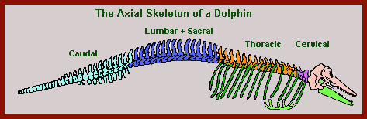
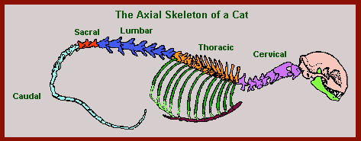

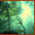 | Deep Time  Explore 4 billion years of life on Earth.
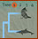All in the Family
Test your skills at judging who's who on the tree of life.
(Flash required) Genetic Tool Kit
One set of genes shared by almost all animals makes myriad life forms possible.
(Video) 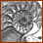Life's Grand Design
Are nature's complex forms evidence of "intelligent design"? Questions about evolution?
Check out the Evolution FAQ.
http://www.pbs.org/wgbh/evolution/change/deeptime/index.html
http://www.pbs.org/wgbh/aso/tryit/dna/shockwave.html

http://www.dnai.org/index.htm

