# DEFINING WEATHER 2017 (Engel’s super earth science savers™ Simonized)

Name\_\_\_\_\_\_\_\_\_\_\_\_\_\_\_\_\_\_\_\_\_\_\_\_\_\_\_\_ Date\_\_\_\_\_\_\_\_\_\_\_\_ Hour\_\_\_\_\_\_\_

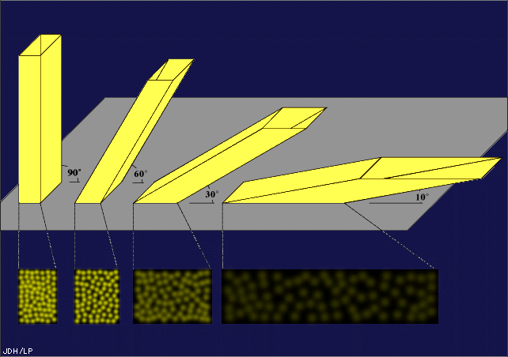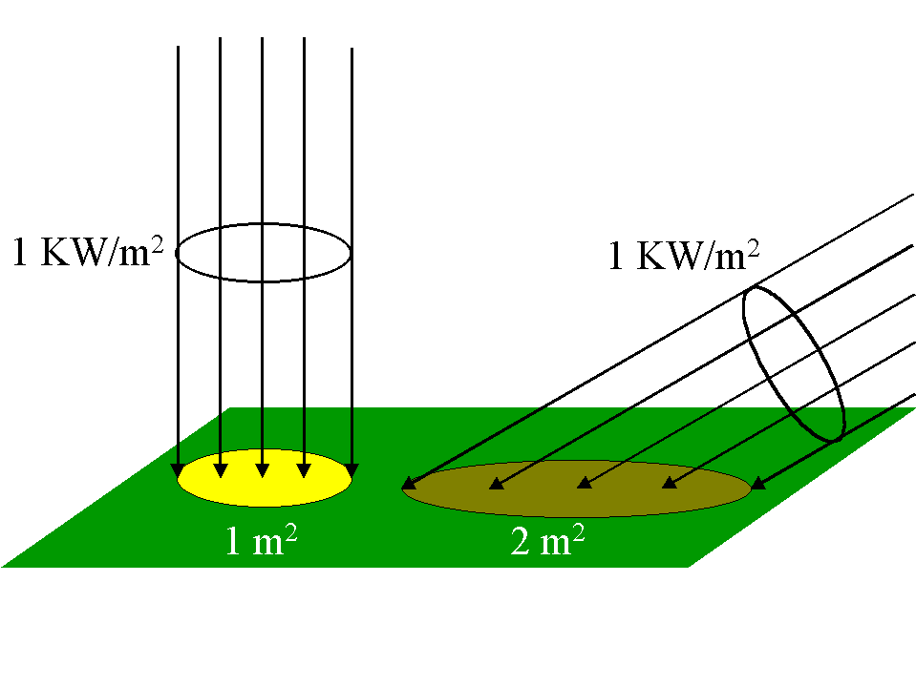All weather is the direct result of the heat transfer that occurs when radiation from the sun heats the earth’s surface unevenly. The heating of the surface of the earth depends on the angle at which the sun’s rays strike the surface. Near the equator, the sun’s rays strike earth most directly. This direct strike focuses the sun’s energy within a small area, heating the surface effectively. However, since the earth’s surface is curved, the sun’s rays strike areas away from the equator at a slanting angle. This slanting angle at which the sun strikes the earth spreads the heat energy over a wider area. This heating method is much less effective. The farther from the equator, the more slanted the sun’s rays and the less effective the rays heat the earth’s surface.

The uneven heating of the earth’s curved surface causes hotter air in the equator to rise and spread to the north and south. The cooler air near the earth’s poles moves toward the equator to replace the warm rising air. This transfer of heat due to density is called **convection.**

## Check for understanding:

1. All weather is the direct result of when the earth’s surface is heated \_\_\_\_\_\_\_\_\_\_\_\_\_\_\_\_\_.

2. The sun’s rays hit the earth most directly at the earth’s \_\_\_\_\_\_\_\_\_\_\_\_\_\_\_\_\_\_\_\_\_\_\_\_.

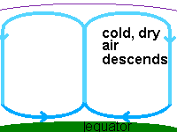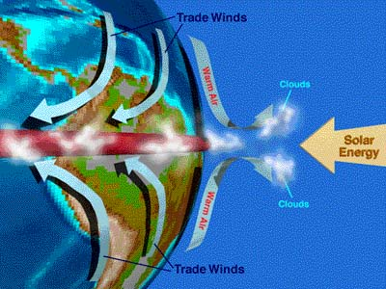

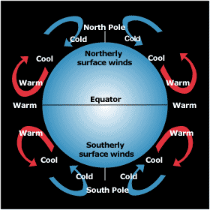

3. Why doesn’t the sun heat the earth evenly? \_\_\_\_\_\_\_\_\_\_\_\_\_\_\_\_\_\_\_\_\_\_\_\_\_\_\_\_\_\_\_\_\_\_\_\_\_\_\_\_\_\_\_\_\_\_\_\_\_\_\_\_\_\_\_\_\_\_\_\_\_\_\_\_\_\_\_\_\_\_\_\_\_\_\_\_\_\_\_\_\_\_\_\_\_\_

\_\_\_\_\_\_\_\_\_\_\_\_\_\_\_\_\_\_\_\_\_\_\_\_\_\_\_\_\_\_\_\_\_\_\_\_\_\_\_\_\_\_\_\_\_\_\_\_\_\_\_\_\_\_\_\_\_\_\_\_\_\_\_\_\_\_\_\_\_\_\_\_\_\_\_\_\_\_\_\_\_\_\_\_\_\_

4. The transfer of heat due to density is called\_\_\_\_\_\_\_\_\_\_\_\_\_\_\_\_\_\_\_\_\_\_\_\_\_\_\_\_\_\_\_\_\_\_.

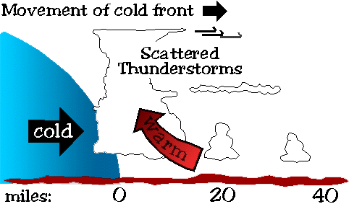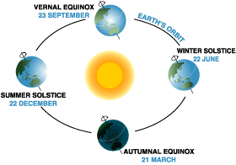

### Where does weather occur?

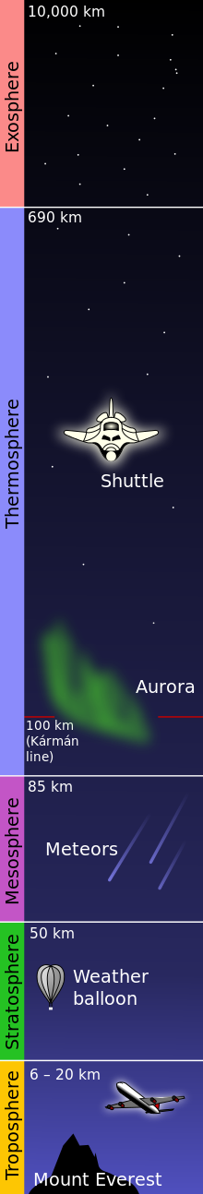The earth is surrounded by a blanket of air that extends to about 600-700 miles above the earth’s surface. The molecules of gas are trapped by the pull of the earth’s gravity. The air mixture in our atmosphere has evolved or changed over time. At the present time, the earth’s atmosphere contains 78% nitrogen, 20.8% oxygen and the remaining 1.2% is a combination of water vapor, carbon dioxide, and argon and other elements. Most of the gases present in the earth’s atmosphere were ejected from the earth’s crust during long periods of volcanic activity. The atmosphere is separated into distinct layers based on the temperature changes that occur from on layer to the next. The five layers of the earth’s atmosphere; troposphere, stratosphere, mesosphere, thermosphere and exosphere are shown in the figure to the right.

The layer of the atmosphere closet to the Earth is the **troposphere.** We live in the troposphere layer and that is where weather occurs. As you go higher in the troposphere the temperature drops as the sun‘s rays heat the earth’s surface not the air directly. Therefore, air close closest to the ground is the warmest. The thickness of the troposphere varies from 17.6 at the equator to 6.4 km at the poles.

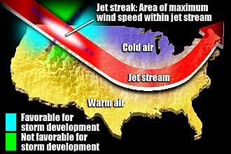The **stratosphere** lies above the troposphere. Air in the stratosphere is thinner than air the troposphere. The air contains very little moisture or dust. As a result of the lack of moisture and dust, weather does not occur in this layer. Ozone is found in this layer about 15-50 km high. Ozone is a form of gas (O3) that absorbs most of the harmful ultraviolet rays from the sun. The stratosphere contains broad, fast-flowing “rivers” of air circulating around the world. These “rivers” of air are called jet streams. The jet streams are narrow bands of strong winds that flow around the earth at speeds of 160 to 400 km/hr. (100-250 mph) and can change the weather patterns in the troposphere.

Above the stratosphere is the **mesosphere** the temperature in the mesosphere reaches –75 c and extends to about 80 km above the earth. Noctilucent clouds (means night shining in Latin.), clouds of water vapor or meteor dust that shine at night are a distinguishable feature of this layer.

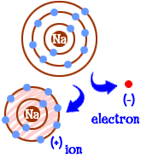The temperature begins to climb in the fourth layer of the atmosphere the **thermosphere.** When the solar energy is absorbed directly by the gas molecules, the atoms may gain or lose electrons thus becoming charged particles called **ions.** These charged particles, ions, are capable of reflecting many types of radio waves like AM or HAM and allowing them to reflect and bounce to distant places.

Mesosphere

Stratosphere

Troposphere

Exosphere

Thermosphere

Ionosphere

The final known layer of the earth’s atmosphere is the **exosphere.** The layer is often referred to as outer space. Very little is known about this layer. Its thickness is still unknown.

### Check for Understanding

5. 78% of the earth’s atmosphere is made of \_\_\_\_\_\_\_\_\_\_\_\_\_\_\_\_\_\_\_\_\_\_\_\_\_\_\_\_\_\_\_

6. 20.8% of the earth’s atmosphere is made of \_\_\_\_\_\_\_\_\_\_\_\_\_\_\_\_\_\_.

7. The remaining 1.2% of the earth’s atmosphere is made of -\_\_\_\_\_\_\_\_\_\_\_\_, \_\_\_\_\_\_\_\_\_\_\_\_\_\_\_\_\_\_ and \_\_\_\_\_\_\_\_\_\_\_\_\_\_\_\_\_\_\_\_\_\_\_\_\_\_\_\_as well as other trace elements.

8. Name the five layers of the atmosphere. \_\_\_\_\_\_\_\_\_\_\_\_\_\_\_\_\_\_\_\_\_, \_\_\_\_\_\_\_\_\_\_\_\_\_\_\_\_\_\_\_\_\_\_\_, \_\_\_\_\_\_\_\_\_\_\_\_\_\_\_\_\_\_\_\_\_\_\_\_\_\_, \_\_\_\_\_\_\_\_\_\_\_\_\_\_\_\_\_\_\_\_\_ and \_\_\_\_\_\_\_\_\_\_\_\_\_\_\_\_\_\_\_\_.

9. What layer of the atmosphere contains the ozone? \_\_\_\_\_\_\_\_\_\_\_\_\_\_\_\_\_\_\_\_\_\_\_\_\_\_

10. What layer of the atmosphere is responsible for the bouncing of AM radio signals? \_\_\_\_\_\_\_\_\_\_\_\_\_\_\_\_\_\_\_\_\_\_\_\_\_\_\_\_\_\_\_\_\_\_\_\_\_\_\_\_\_\_\_\_\_\_\_\_\_\_\_\_\_\_\_\_\_\_\_\_\_\_\_\_\_\_\_\_\_\_\_\_\_\_\_\_\_\_

11. What layer of the atmosphere contains weather? \_\_\_\_\_\_\_\_\_\_\_\_\_\_\_\_\_\_\_\_\_\_\_\_\_\_\_\_\_\_\_\_\_\_\_\_

12. In what layer of the atmosphere would find stars and all the other celestial bodies? \_\_\_\_\_\_\_\_\_\_\_\_\_\_\_\_\_\_\_\_\_\_\_\_\_\_\_\_\_\_\_\_\_\_\_\_\_\_\_\_\_\_\_\_\_\_\_\_\_\_\_\_\_\_\_\_\_\_\_\_\_\_\_\_\_\_\_\_\_\_\_\_\_\_\_\_\_\_\_

13. What layer of the atmosphere has the highest temperature? \_\_\_\_\_\_\_\_\_\_\_\_\_\_\_\_\_\_\_\_\_\_\_\_\_\_\_\_\_\_\_\_\_\_\_\_\_\_\_\_\_\_\_\_\_\_\_\_\_\_\_\_\_\_\_\_\_\_\_\_\_\_\_\_\_\_\_\_\_\_\_\_\_\_\_\_\_\_\_\_

14. What is a jet stream? \_\_\_\_\_\_\_\_\_\_\_\_\_\_\_\_\_\_\_\_\_\_\_\_\_\_\_\_\_\_\_\_\_\_\_\_\_\_\_\_\_\_\_\_\_\_\_\_\_\_\_\_\_\_\_\_\_\_\_\_ \_\_\_\_\_\_\_\_\_\_\_\_\_\_\_\_\_\_\_\_\_\_\_\_\_\_\_\_\_\_\_\_\_\_\_\_\_\_\_\_\_\_\_\_\_\_\_\_\_\_\_\_\_\_\_\_\_\_\_\_\_\_\_\_\_\_\_\_\_\_\_\_\_\_\_\_\_\_\_\_\_

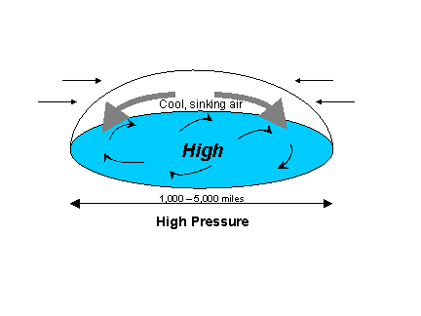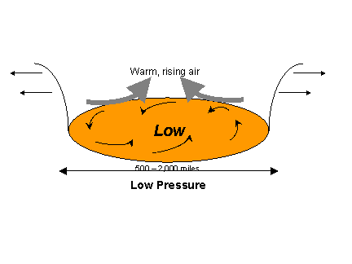15. How does the jet stream and weather interact (work-together)? \_\_\_\_\_\_\_\_\_\_\_\_\_\_\_\_\_\_\_\_\_\_\_\_\_\_\_\_\_\_\_\_\_\_\_\_\_\_\_\_\_\_\_\_\_\_\_\_\_\_\_\_\_\_\_\_\_\_\_\_\_\_\_\_\_\_\_\_\_\_\_\_\_\_\_\_\_\_\_\_\_\_\_\_\_\_\_\_\_\_\_\_\_\_\_\_\_\_\_\_\_\_\_\_\_\_\_\_\_\_\_\_\_\_\_\_\_\_\_\_\_\_\_\_\_\_\_\_\_\_\_\_\_\_\_\_\_\_\_\_\_\_\_\_\_\_\_\_\_\_\_\_\_\_\_\_\_\_\_\_\_\_\_\_\_\_\_\_\_\_

# What are the elements that make up weather?

#### air_masses1Temperature, pressure, movement and moisture are the four critical elements that determine weather. Air covers every inch of the earth’s surface. Earth’s gravity pulls on this air. Each square inch of this air weighs 14.7 lbs (6.6 kg). This weight is known as air pressure. An air mass is a large body of air that has similar temperature and moisture properties throughout. The best areas for air masses to form are large flat areas where air can stay in one place long enough to take on the characteristics of the surface below. [Maritime tropical air masses (mT)](http://ww2010.atmos.uiuc.edu/(Gh)/wwhlpr/tropical_airmass_def.rxml?hret=/guides/mtr/af/arms/home.rxml), for example, comes from the subtropical oceans and transport heat and moisture northward into the U.S. On the other side, [continental polar air masses (cP)](http://ww2010.atmos.uiuc.edu/(Gh)/wwhlpr/arctic_airmass_def.rxml?hret=/guides/mtr/af/arms/home.rxml), which comes from over the northern plains of Canada, transports colder and drier air southward. Once an air mass moves out of its source region, it changes slightly as it flows across different surface conditions than those found in the source region. For example, as a polar air mass moves southward, it encounters warmer land masses and because of this, is heated by the ground below. Air masses clash in the middle latitudes where we live, making some very interesting weather.

When cool, dense air presses down on the earth, the air pressure is high. Warm, less dense air rises away from the earth, generally producing low pressure. High pressure usually brings clear weather, while low pressure brings bad weather and stronger winds.

**Fronts** -The boundaries between air masses

A front is defined as the transition zone between two [air masses](http://ww2010.atmos.uiuc.edu/(Gh)/wwhlpr/air_masses.rxml?hret=/guides/mtr/af/frnts/home.rxml) of different density. Fronts extend not only in the horizontal direction, but in the vertical as well.

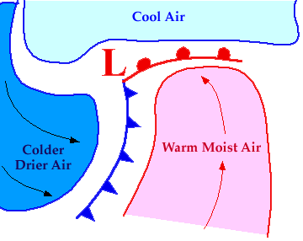

[**www.windows.ucar.edu/.../ tstorm/cold\_front.html**](http://www.windows.ucar.edu/tour/link=/earth/Atmosphere/tstorm/cold_front.html)

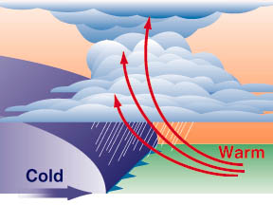

- [**Cold Front**](http://ww2010.atmos.uiuc.edu/(Gh)/guides/mtr/af/frnts/cfrnt/def.rxml) **-** Leading edge of colder air

that is replacing warmer air.

****[**Stationary Front**](http://ww2010.atmos.uiuc.edu/(Gh)/guides/mtr/af/frnts/sfdef.rxml) -A front that is not moving.

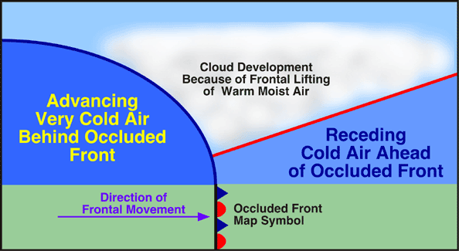

[**Occluded Front**](http://ww2010.atmos.uiuc.edu/(Gh)/guides/mtr/af/frnts/ofdef.rxml) -When a cold front catches up to a cold/warm front.

When air masses meet (high and low pressure systems), they do not mix. Instead they form a front, which can be hundreds of miles long. The front is called a cold front when a cold air mass replaces a warmer air mass by forcing it to rise rapidly.

A **cold front** moves quickly. If the air is dry or lacking moisture then the weather will become cloudy and the temperature will drop. If the air is moist, a cold front will bring violent thunderstorms and hail, but they won’t last long. The amount of moisture, water vapor, in the air depends on the temperature of the air. When the air mass is cold, the molecules are very dense, close together. This closeness does not allow a lot of space for water vapor to bounce between molecules and remain suspend. As a result of the lack of water vapor riding in a cold air mass the precipitation following a cold front does not last long. (Downpours)

A **warm front** occurs when a warm or warmer air mass moves into a cold or cooler air mass. A warm front is the boundary between warm and cool, or cold, air when the warm air is replacing the cold air. That sounds like what you want. However, warm fronts often bring days of inclement weather. (Drizzle for days)

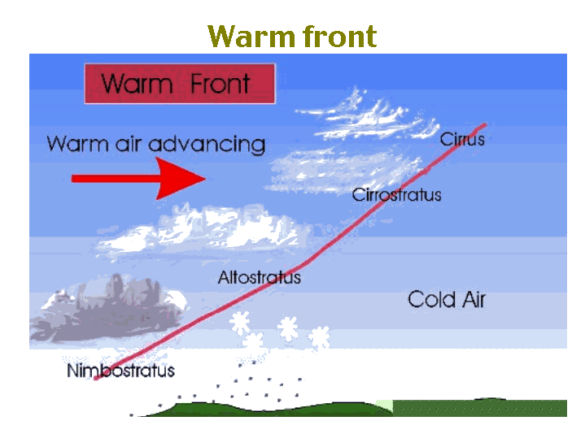

[**www.ars.usda.gov/is/ kids/water/story2/vapor.htm**](http://www.ars.usda.gov/is/kids/water/story2/vapor.htm)

Warm fronts often form to the east of low pressure centers, where southerly winds push warm air northward. A warm front moves in slowly. If the air is dry, then wispy clouds will form. If the air is moist, the sky will become gray and the drizzle or snow flurries that follow may last for days. After the warm front moves on, usually there will be fair weather. When cold and warm air masses meet and neither mass moves, it is called a **stationary front**.



16. What are the four essential elements of weather? \_\_\_\_\_\_\_\_\_\_\_\_\_\_\_\_\_\_, \_\_\_\_\_\_\_\_\_\_\_\_\_\_\_\_\_\_\_\_\_, \_\_\_\_\_\_\_\_\_\_\_\_\_\_\_\_\_\_\_\_\_\_ and\_\_\_\_\_\_\_\_\_\_\_\_\_\_\_\_\_\_.

17. The air surrounding the earth is pulled towards earth by \_\_\_\_\_\_\_\_\_\_\_\_\_\_\_\_\_\_\_\_.

18. The force of gravity pulling the air toward earth’s center of gravity is called \_\_\_\_\_\_\_\_\_\_\_\_\_\_\_\_\_\_\_\_\_\_\_\_\_\_\_\_\_\_\_\_\_\_\_\_\_\_\_\_\_\_\_\_\_\_\_\_\_\_\_\_\_\_\_\_.

19. Define high pressure and the weather it produces.\_\_\_\_\_\_\_\_\_\_\_\_\_\_\_\_\_\_\_\_\_\_\_\_\_\_\_\_\_\_\_\_\_\_\_\_\_\_

\_\_\_\_\_\_\_\_\_\_\_\_\_\_\_\_\_\_\_\_\_\_\_\_\_\_\_\_\_\_\_\_\_\_\_\_\_\_\_\_\_\_\_\_\_\_\_\_\_\_\_\_\_\_\_\_\_\_\_\_\_\_\_\_\_\_\_\_\_\_\_\_\_\_\_\_\_\_\_\_\_\_

20. Define low pressure and the weather it produces. .\_\_\_\_\_\_\_\_\_\_\_\_\_\_\_\_\_\_\_\_\_\_\_\_\_\_\_\_\_\_\_\_\_\_\_\_\_\_

\_\_\_\_\_\_\_\_\_\_\_\_\_\_\_\_\_\_\_\_\_\_\_\_\_\_\_\_\_\_\_\_\_\_\_\_\_\_\_\_\_\_\_\_\_\_\_\_\_\_\_\_\_\_\_\_\_\_\_\_\_\_\_\_\_\_\_\_\_\_\_\_\_\_\_\_\_\_\_\_\_\_

21. The zone located at the intersection of a cold and warm mass is called a \_\_\_\_\_\_\_\_\_\_\_\_\_\_\_\_\_\_\_\_\_

\_\_\_\_\_\_\_\_\_\_\_\_\_\_\_\_\_\_\_\_\_\_\_\_\_\_\_\_\_\_\_\_\_\_\_\_\_\_\_\_\_\_\_\_\_\_\_\_\_\_\_\_\_\_\_\_\_\_\_\_\_\_\_\_\_\_\_\_\_\_\_\_\_\_\_\_\_\_\_\_\_\_\_\_\_\_

22. Define a warm front and the weather it produces.\_\_\_\_\_\_\_\_\_\_\_\_\_\_\_\_\_\_\_\_\_\_\_\_\_\_\_\_\_\_\_\_\_\_\_\_\_\_\_\_ \_\_\_\_\_\_\_\_\_\_\_\_\_\_\_\_\_\_\_\_\_\_\_\_\_\_\_\_\_\_\_\_\_\_\_\_\_\_\_\_\_\_\_\_\_\_\_\_\_\_\_\_\_\_\_\_\_\_\_\_\_\_\_\_\_\_\_\_\_\_\_\_\_\_\_\_\_\_\_\_\_\_\_\_\_\_

23. Define a cold front and the weather it produces.\_\_\_\_\_\_\_\_\_\_\_\_\_\_\_\_\_\_\_\_\_\_\_\_\_\_\_\_\_\_\_\_\_\_\_\_\_\_\_

\_\_\_\_\_\_\_\_\_\_\_\_\_\_\_\_\_\_\_\_\_\_\_\_\_\_\_\_\_\_\_\_\_\_\_\_\_\_\_\_\_\_\_\_\_\_\_\_\_\_\_\_\_\_\_\_\_\_\_\_\_\_\_\_\_\_\_\_\_\_\_\_\_\_\_\_\_\_\_\_

24. What is the name of the front that is formed when a warm air mass and a cold air mass meet and neither mass moves? \_\_\_\_\_\_\_\_\_\_\_\_\_\_\_\_\_\_\_\_\_\_\_\_\_\_\_\_\_\_\_\_\_\_\_\_\_\_\_\_\_\_\_\_\_\_\_\_\_\_.

**How is weather monitored and predicted?**

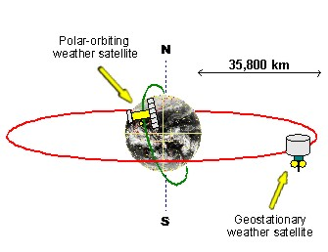Weather satellites are spacecraft, which collect and relay weather information to earth. Before the first weather satellite was launched in 1960, forecasters could not reliably track weather across the oceans, which cover most of the earth, because of the great distances.

There are two types of satellites. **Polar orbiting** **satellites** circle the earth from pole to pole, completing one orbit every 100 minutes. These satellites orbit at an altitude of about 500 miles above the earth's surface and provide coverage of the entire earth four times a day. The second type of weather satellite is the geo-stationary. **Geo-stationary satellites** orbit the earth at the same rate that the earth rotates, so the satellite is always seeing the same part of the earth. Since geo-stationary satellites rotate at the same rate as the earth, they complete one orbit every twenty-four hours. Geo-stationary satellites are located at a much higher altitude than polar orbiting satellites, positioned at 22,300 miles above the earth's surface. Under normal operating conditions two geo-stationary satellites observe the Eastern and Western United States, adjacent oceans and a large part of the Southern Hemisphere.

Both types of satellites transmit image data down to earth. Image data are visible color-coded pictures representing weather patterns. This data can be visible as a result of the sun reflecting off clouds or it can be the result of infrared radiation. In other words, the satellite can detect the amount of infrared radiation or heat the earth is giving off.

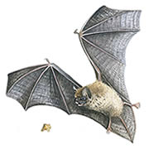 Radar is also used to track and predict weather. RADAR stands for Radio detection and Ranging. Radar is a radio transmitter that sends out sound signals that bounce off rain or snow. When the sound wave bounces off the snow or rain droplets the signal returns to the dish, which sends he information to a nearby computer. The computer is able to quickly calculate the amount, size and location of the precipitation. Radar works like the echolocation devices, sonar, found in animals such as bats and dolphins and machinery such as submarines.

The latest or newest weather detecting devise is Doppler radar. Doppler radar allows meteorologists to detect precipitation and wind circulation within a cloud. By seeing the wind pattern within a storm, meteorologists may be able to tell if a tornado is forming.

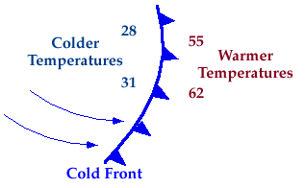 All the data collected by the different satellites and radars are then tracked and recorded on weather maps. Cold fronts are labeled by using blue lines with pointed icicles. The pointed icicles indicate the direction the cold front is moving.

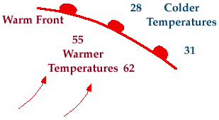Red lines with rounded bumps depict a warm front.

The rounded bumps indicate the direction the warm front is moving. A stationary front contains both pointed and rounded bumps. High-pressure systems are indicated by a capital "H" and Low-pressure systems by the capital letter "L".

23. When was the first weather satellite launched? \_\_\_\_\_\_\_\_\_\_\_\_\_\_

24. Name the two types of satellites. \_\_\_\_\_\_\_\_\_\_\_\_\_\_\_\_\_\_ and \_\_\_\_\_\_\_\_\_\_\_\_\_\_\_\_\_\_\_\_\_\_

25. How often do polar satellites revolve around the earth? \_\_\_\_\_\_\_\_\_\_\_\_\_\_\_\_\_\_\_\_\_\_\_\_\_\_\_\_\_\_\_\_\_

26. How often do geo-stationary satellites orbit around the earth? \_\_\_\_\_\_\_\_\_\_\_\_\_\_\_\_\_\_\_\_\_\_\_\_\_\_\_

27. Other than the amount of time that each satellite takes to orbit the earth, how are they different?

\_\_\_\_\_\_\_\_\_\_\_\_\_\_\_\_\_\_\_\_\_\_\_\_\_\_\_\_\_\_\_\_\_\_\_\_\_\_\_\_\_\_\_\_\_\_\_\_\_\_\_\_\_\_\_\_\_\_\_\_\_\_\_\_\_\_\_\_\_\_\_\_\_\_\_\_\_\_\_\_\_\_\_\_\_\_\_\_\_\_\_\_\_\_\_\_\_\_\_\_\_\_\_\_\_\_\_\_\_\_\_\_\_\_\_\_\_\_\_\_\_\_\_\_\_\_\_\_\_\_\_\_\_\_\_\_\_\_\_\_\_\_\_\_\_\_\_\_\_\_\_\_\_\_\_\_\_\_\_\_\_\_\_\_\_\_\_\_\_\_\_

28. What does RADAR stand for and how does RADAR work? \_\_\_\_\_\_\_\_\_\_\_\_\_\_\_\_\_\_\_\_\_\_\_\_\_\_\_\_\_\_\_\_ \_\_\_\_\_\_\_\_\_\_\_\_\_\_\_\_\_\_\_\_\_\_\_\_\_\_\_\_\_\_\_\_\_\_\_\_\_\_\_\_\_\_\_\_\_\_\_\_\_\_\_\_\_\_\_\_\_\_\_\_\_\_\_\_\_\_\_\_\_\_\_\_\_\_\_\_\_\_\_\_\_\_\_\_

29. How is radar like the sonar used by animals and submarines? \_\_\_\_\_\_\_\_\_\_\_\_\_\_\_\_\_\_\_\_\_\_\_\_\_\_\_\_\_\_\_ \_\_\_\_\_\_\_\_\_\_\_\_\_\_\_\_\_\_\_\_\_\_\_\_\_\_\_\_\_\_\_\_\_\_\_\_\_\_\_\_\_\_\_\_\_\_\_\_\_\_\_\_\_\_\_\_\_\_\_\_\_\_\_\_\_\_\_\_\_\_\_\_\_\_\_\_\_\_\_\_\_\_\_\_

30. What is the big advantage of Doppler radar? \_\_\_\_\_\_\_\_\_\_\_\_\_\_\_\_\_\_\_\_\_\_\_\_\_\_\_\_\_\_\_\_\_\_\_\_\_\_\_\_\_\_\_\_\_ \_\_\_\_\_\_\_\_\_\_\_\_\_\_\_\_\_\_\_\_\_\_\_\_\_\_\_\_\_\_\_\_\_\_\_\_\_\_\_\_\_\_\_\_\_\_\_\_\_\_\_\_\_\_\_\_\_\_\_\_\_\_\_\_\_\_\_\_\_\_\_\_\_\_\_\_\_\_\_\_\_\_\_\_\_ \_\_\_\_\_\_\_\_\_\_\_\_\_\_\_\_\_\_\_\_\_\_\_\_\_\_\_\_\_\_\_\_\_\_\_\_\_\_\_\_\_\_\_\_\_\_\_\_\_\_\_\_\_\_\_\_\_\_\_\_\_\_\_\_\_\_\_\_\_\_\_\_\_\_\_\_\_\_\_\_\_\_\_\_

<http://www.suu.edu/faculty/colberg/Hazards/Weather/20_nTwinds.html>

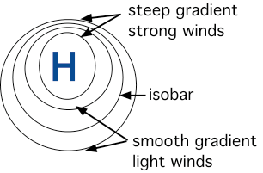

**Isobars** can be used to identify "Highs" and "Lows". Isobars are lines that connect areas of equal atmospheric pressure. Much like how topographic lines that are close together on a topographic map indicate a steep slope; on a weather map, isobars that are close together indicate a strong pressure gradient, which results in high winds.

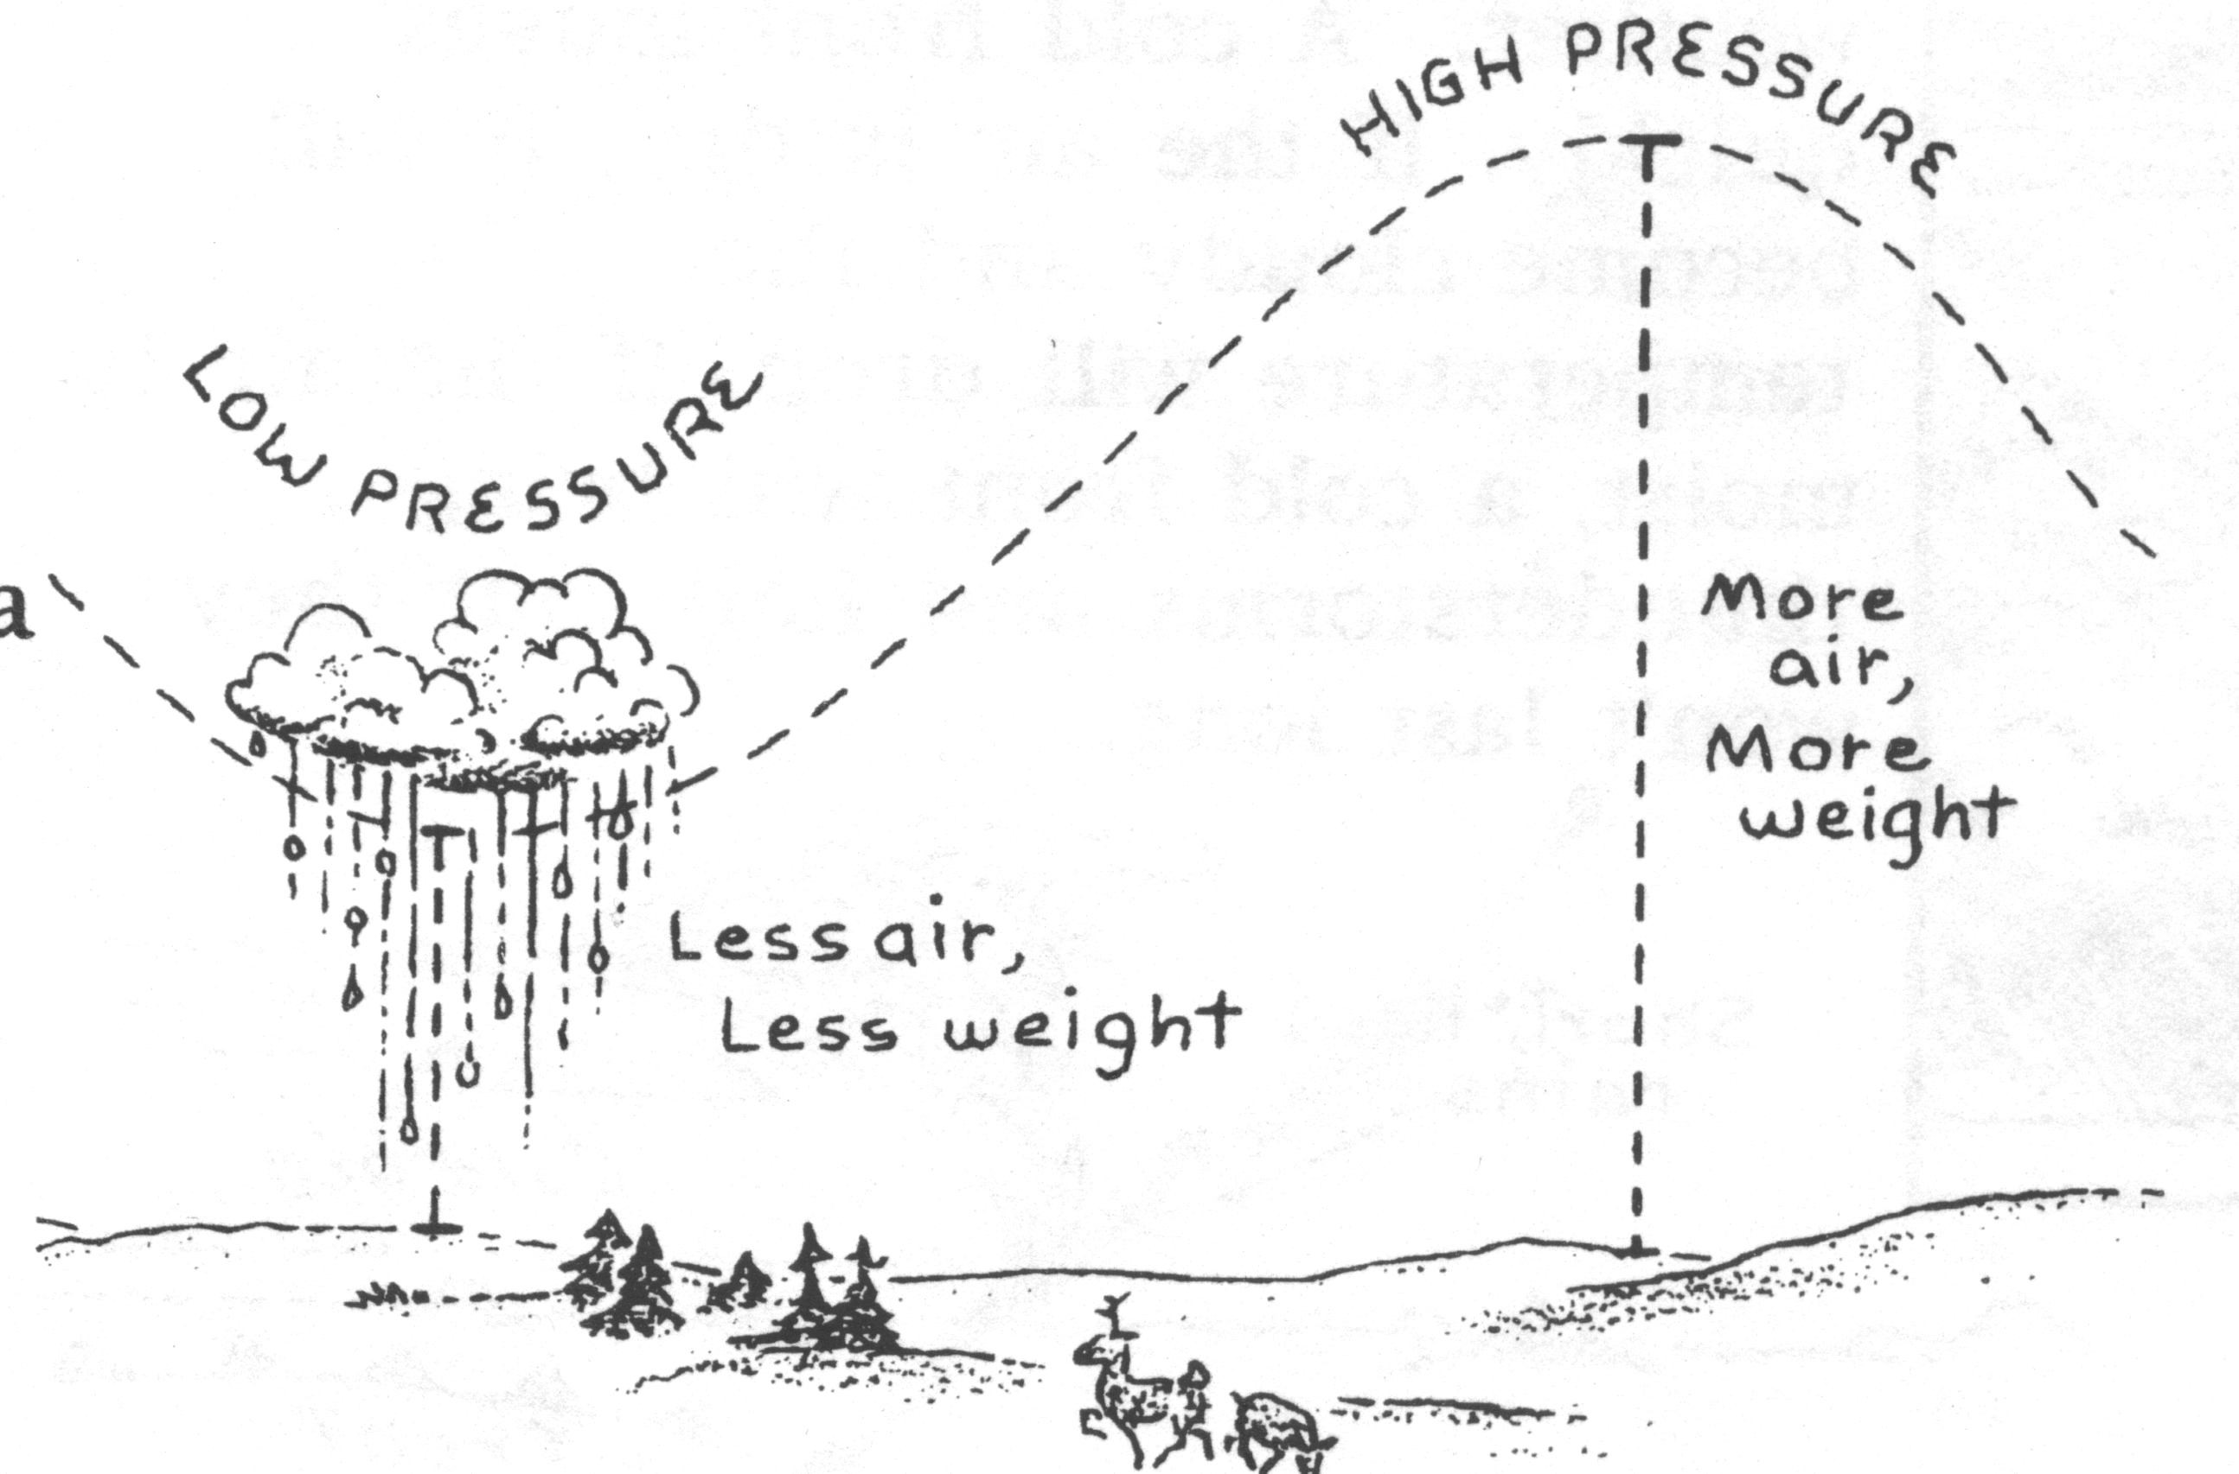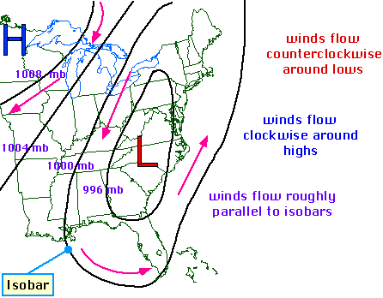

31. Isobars are lines on a weather map that connect areas of equal \_\_\_\_\_\_\_\_\_\_\_\_\_\_\_\_\_\_\_\_\_\_\_\_\_\_\_\_\_\_\_\_.

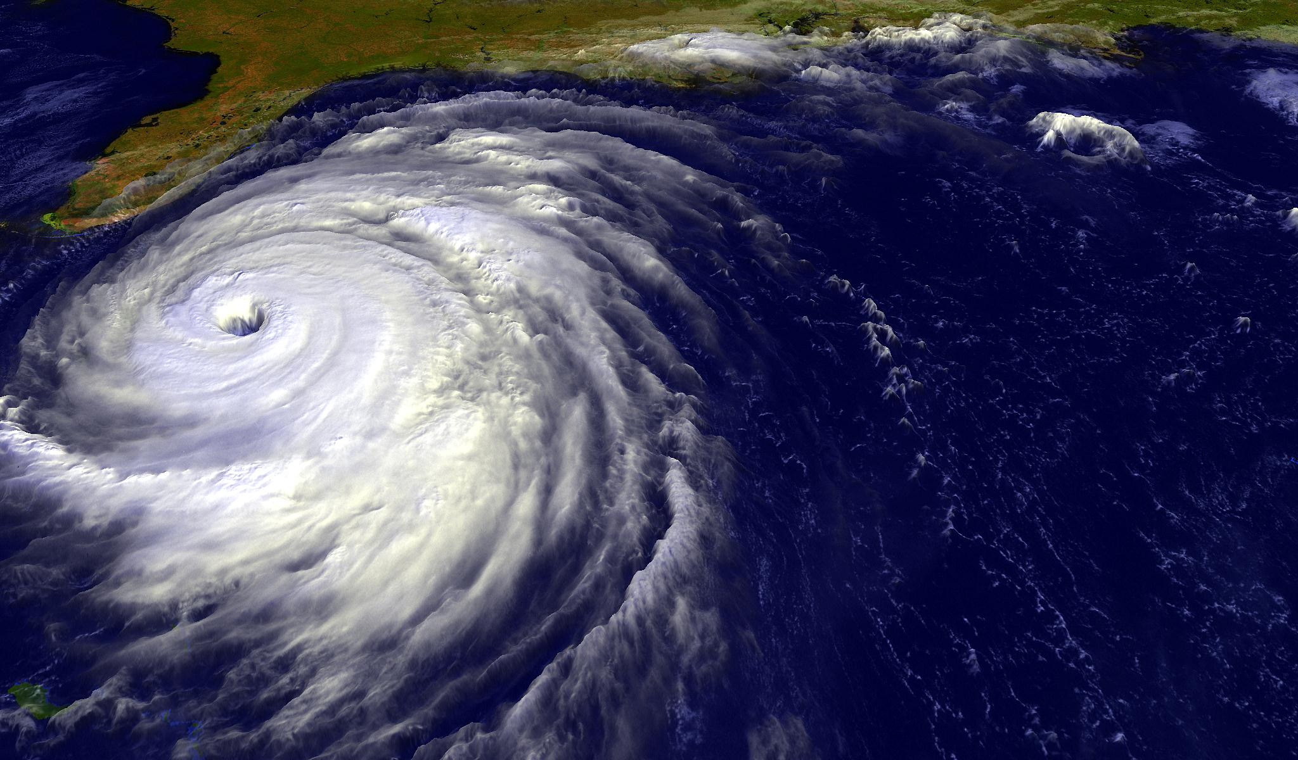

32. If the isobars on a weather map are close together this indicates what type of wind?

\_\_\_\_\_\_\_\_\_\_\_\_\_\_\_\_\_\_\_\_\_\_\_\_\_\_\_\_\_

As fuel, **hurricanes** need convection and very high relative humidity, or very moist air, found above warm tropical ocean waters near the equator. These monster “thunderstorms” are spun by the Earth’s rotation (the Coriolis Effect) into an apocalyptic, super-duper, spinning storm wheels of death known as hurricanes (in the Atlantic Ocean) , or typhoons (in the Pacific). Fun Fact: Australia calls them “Willy-willies.” <http://www.suu.edu/faculty/colberg/Hazards/Weather/34_Coriolis.html>

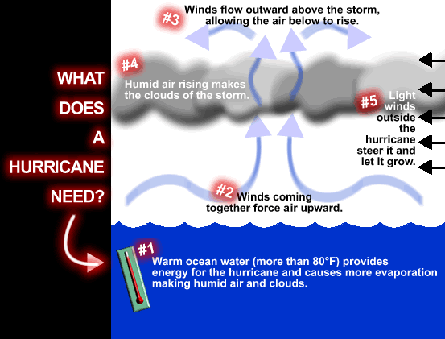

Using the graphic at the right to answer the question below.

3131. 33. The intensity and even the possible creation of a hurricane are based on five things:

(1) \_\_\_\_\_\_\_\_\_\_\_\_\_\_\_\_\_\_\_\_\_\_\_\_\_\_\_\_\_\_\_\_\_\_\_\_\_\_\_\_\_\_\_\_\_\_\_\_\_\_\_\_\_\_\_\_\_\_\_\_\_\_\_\_\_\_\_\_\_\_\_\_\_\_\_\_\_\_,

(2) \_\_\_\_\_\_\_\_\_\_\_\_\_\_\_\_\_\_\_\_\_\_\_\_\_\_\_\_\_\_\_\_\_\_\_\_\_\_\_\_\_\_\_\_\_\_\_\_\_\_\_\_\_\_\_\_\_\_\_\_\_\_\_\_\_\_\_\_\_\_\_\_\_\_\_\_\_\_,

(3) \_\_\_\_\_\_\_\_\_\_\_\_\_\_\_\_\_\_\_\_\_\_\_\_\_\_\_\_\_\_\_\_\_\_\_\_\_\_\_\_\_\_\_\_\_\_\_\_\_\_\_\_\_\_\_\_\_\_\_\_\_\_\_\_\_\_\_\_\_\_\_\_\_\_\_\_\_\_,

(4) \_\_\_\_\_\_\_\_\_\_\_\_\_\_\_\_\_\_\_\_\_\_\_\_\_\_\_\_\_\_\_\_\_\_\_\_\_\_\_\_\_\_\_\_\_\_\_\_\_\_\_\_\_\_\_\_\_\_\_\_\_\_\_\_\_\_\_\_\_\_\_\_\_\_\_\_\_\_,

(5) \_\_\_\_\_\_\_\_\_\_\_\_\_\_\_\_\_\_\_\_\_\_\_\_\_\_\_\_\_\_\_\_\_\_\_\_\_\_\_\_\_\_\_\_\_\_\_\_\_\_\_\_\_\_\_\_\_\_\_\_\_\_\_\_\_\_\_\_\_\_\_\_\_\_\_\_\_\_,

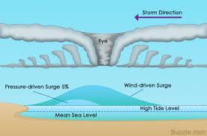One of the most dangerous and damaging aspects of a hurricane, besides the winds, is the flooding caused along the shoreline due to the hurricane’s “storm surge.”

How do tornadoes form?

<http://www.usatoday.com/weather/graphics/tornadoes/flash.htm>

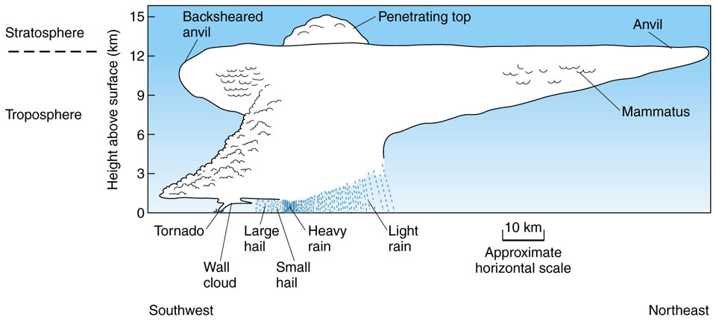Most tornadoes form from thunderstorms. Although we don’t know a lot about tornadoes a typical one may form under these conditions. When warm moist Gulf air meets dry, cold Canadian air, the warm moist air is less dense than the cold dry air and the two create instability in the atmosphere. As this warm moist air rises, it may meet varying winds from different directions and altitudes. If the winds are just right they will act on this rising air like a spinning top creating an invisible, horizontal spinning effect in the lower atmosphere (like rolling a pencil between your two hands). Rising air within the updraft tilts the rotating air from horizontal to vertical. An area of rotation, 2-6 miles wide, now extends through much of the storm. Most strong and violent tornadoes form within this area of strong rotation.

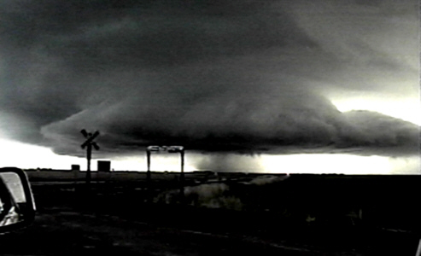 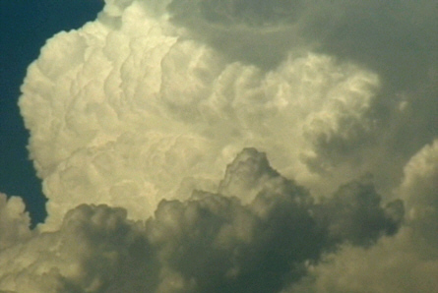

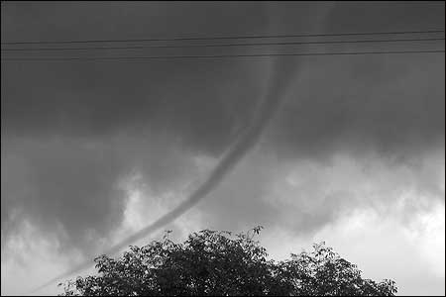A wall cloud is an abrupt lowering of a rain-free cumulonimbus base into a low-hanging accessory cloud. A wall cloud is usually situated in the southwest portion of the storm. A rotating wall cloud usually develops before tornadoes or funnel clouds. The funnel cloud one sees is a rotating cone-shaped column of air extending downward from the base of a thunderstorm, but not touching the ground. Once it reaches the ground it is called a tornado.

Tornadoes can form out of many kinds of storms, but the type most likely to produce tornadoes is the 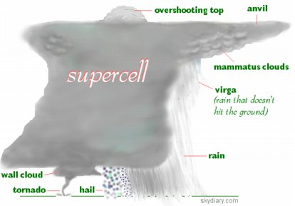**supercell**. A supercell has an area of rotation within the storm called a **mesocyclone** that can spawn a tornado. A supercell thunderstorm (a long-lived thunderstorm whose updrafts and downdrafts are in near balance) have the greatest tendency to produce tornadoes that stay on the ground for long periods of time. Supercell thunderstorms can produce violent tornadoes with winds exceeding 200 mph.Tornadoes can happen at any time of the year and at any time of the day. In the Great Lakes peak tornado season is during the summer. In the southern states peak season is from March through May, with a few southern states having a second peak time for tornadoes in the fall. Tornadoes seem most likely to occur between 3 p.m. and 9 p.m.

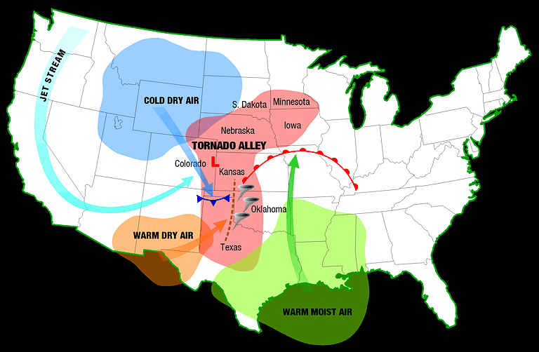The geography of the central part of the United States, known as the Great Plains, is suited to bring all of the ingredients together to forms tornadoes. More than 500 tornadoes typically occur in this area every year and is why it is commonly known as "Tornado Alley.”

<http://www.outlook.noaa.gov/tornadoes/>

In the event of a tornado:

**How to protect yourself: Know your community’s warning system.**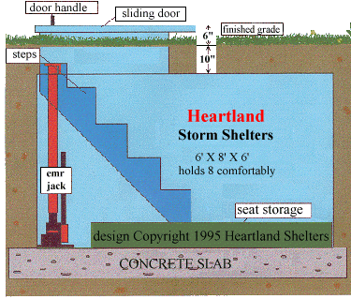

In case of a tornado, identify a safe room where family members and pets can gather in a tornado. It could be your basement, storm cellar, or a windowless interior room on the lowest floor. Prepare for high winds by removing diseased or damaged limbs from trees. Move or secure lawn furniture, trash cans, or anything else that can be picked up by the wind.

Watch for tornado danger signs, such as dark, often greenish clouds; a wall cloud; cloud of debris; large hail, a roaring noise, or a funnel cloud.

Loss of property, personal injury, and loss of life can be reduced through the application of forecasting technology like radar and weather satellites.

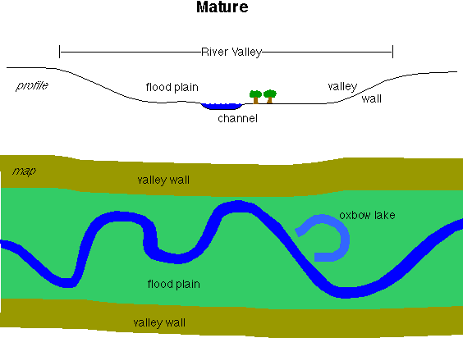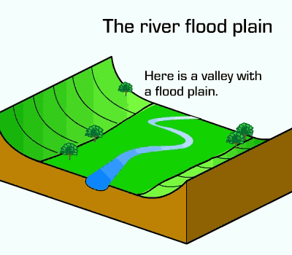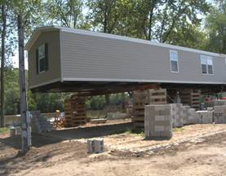**Reducing Flood Damage** A flood occurs when a large rainfall over several days, intense rainfall over a short period of time, or an ice or debris jam causes a river or stream to overflow and flood the surrounding area. Melting snow can combine with rain in the winter and early spring; severe thunderstorms can bring heavy rain in the spring and summer; or tropical cyclones can bring intense rainfall to the coastal and inland states in the summer and fall. Building homes in flood plains or hurricane storm surge areas on piles or elevated can reduce damage due to flooding or hurricane storm surge. By monitoring climate and floods and flood potential, residents and government officials can then make informed decisions on land building codes

Floods and droughts can be forecasted on global scale by using ocean temperatures to predict the amounts of evaporation that will occur. In Michigan during El Nino years where there is a southern oscillation (Like 2010) we are more likely to be dry and warmer than usual. This lack of snowfall upsets people like farmers who depend on the snow to capture nitrogen and as the snow melts, fertilize the soil.

Rain Shadows

**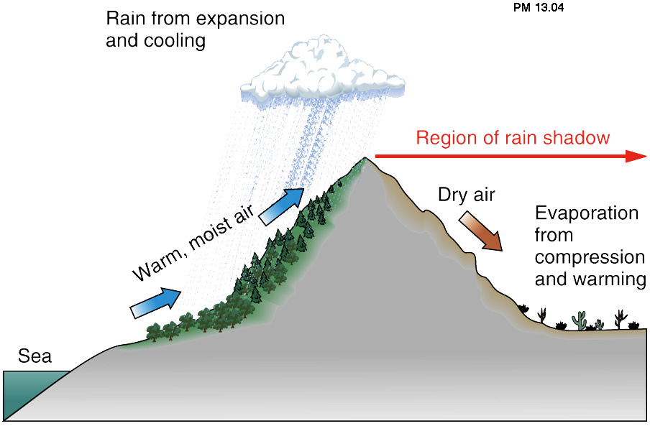Orographic precipitation** is shown to the right. Moist air moves toward higher terrain - usually large mountain chains but smaller block mountains can also cause the effect. At the lower temperatures, the moist air mass becomes saturated and precipitation ensues - usually as thunderstorms in the summer or as widespread snow storms in the winter. This air then becomes "dried out" - most of its moisture has precipitated in the pass over. The air moves down the opposite slope as dry and then warmer air. This side of the mountain is said to be in a "rain shadow". Therefore a rain shadow is an area of dry land that lies on the leeward (or downwind) side of a mountain. The resulting profile of precipitation across the mountain is such that rainfall and moist air prevails on the windward side of a mountain range while arid, moisture-poor air prevails on the leeward side of the mountain range.

**Aquifers or Water tables**

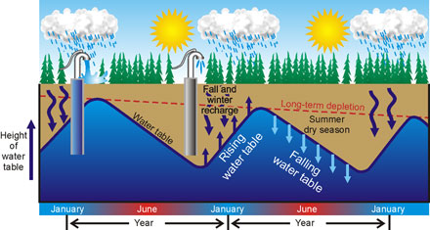The **water table** is the level at which the groundwater pressure is equal to [atmospheric pressure](http://en.wikipedia.org/wiki/Atmospheric_pressure). The distance from the ground surface to the water table changes from place to place - it may be only a few feet, or several hundred feet beneath the surface. Generally, the water table is deeper beneath hills and shallower beneath valleys. It is hardly ever flat! In any one place the water table usually rises with increased recharge from precipitation and shrinks in depth in response to seasonally dry weather, drought, or excessive pumping of ground water.

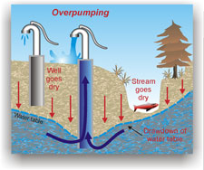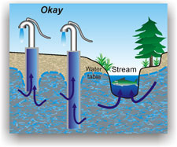

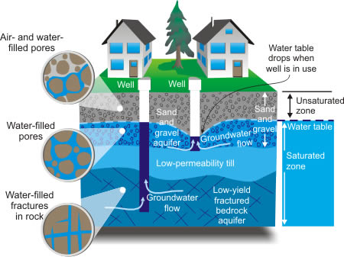**Porosity** is expressed as the ratio of pore space to solid material. For example, saturated sand may have 30% pore space to 70% solid material, while fractured granite may have 1% pore space to 99% solid rock. The sand is more porous than the fractured granite.

**Reasons for the Seasons** –

During the year, the seasons change depending on the amount of sunlight reaching the [Earth](http://www.windows.ucar.edu/tour/link=/earth/earth.html) as it revolves around the [Sun](http://www.windows.ucar.edu/tour/link=/sun/sun.html).

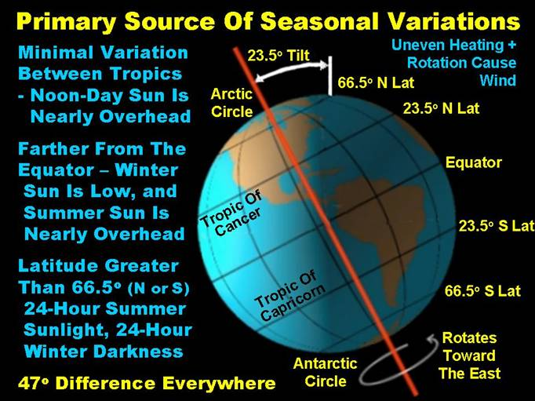The seasons are caused as the Earth, [tilted](http://www.windows.ucar.edu/tour/link=/the_universe/uts/earth2.html) on its axis, travels in a loop around the Sun each year. Summer happens in the hemisphere tilted towards the Sun, and winter happens in the hemisphere tilted away from the Sun. As the Earth travels around the Sun, the hemisphere that is tilted towards or away from the Sun changes.

The hemisphere that is tilted towards the Sun is warmer because sunlight travels more directly to the Earth’s surface so less gets scattered in the atmosphere. That means that when it is summer in the Northern Hemisphere, it is winter in the Southern Hemisphere. The [hemisphere](http://www.windows.ucar.edu/tour/link=/the_universe/uts/seasons3.html) tilted towards the Sun has longer days and shorter nights. That’s why days are longer during the summer than during the winter.

In general, the further away from the equator you travel, the cooler summer and winter temperatures become. At the equator there are no seasons because each day the Sun strikes at about the same angle. Every day of the year the equator receives about 12 hours of sunlight. The poles remain cool because they are never tilted in a direct path of sunlight. Much light is scattered by the atmosphere before reaching the Earth surface at the poles. During midwinter, when a pole is tilted away from the Sun, there is no daylight at all. The sun never rises! However, during the summer, a pole receives sunlight all the time and there is no night!

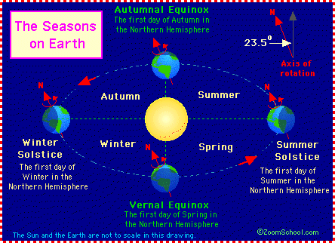

Because the earth’s surface is curved, the sun’s radiation is spread out over the surface in different amounts because of the 23.5 degree tilt of the earth. Radiation from the Sun creates temperature differences in water, land, and the atmosphere, drives local, regional, and global patterns of atmospheric circulation.