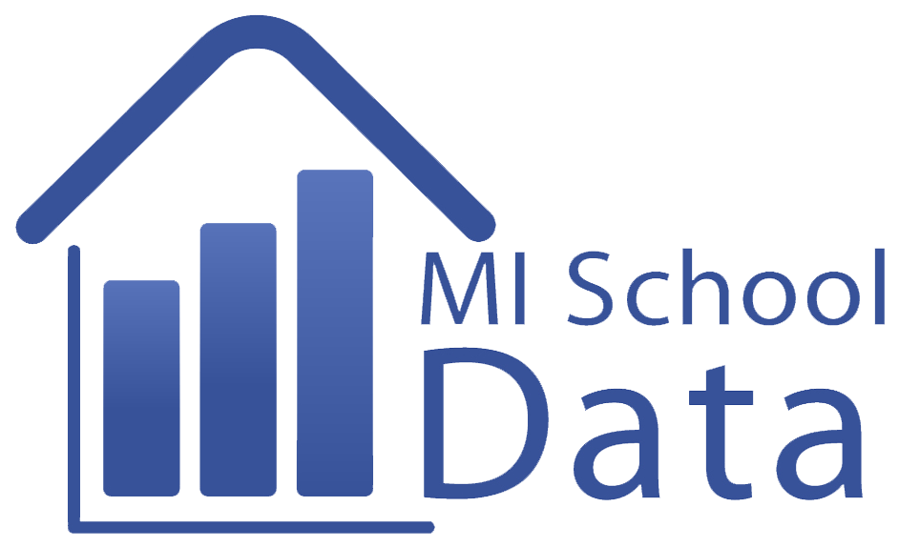Tour of the MISchoolData Dashboard

Obtain a MiSchoolData Login and Password. Record them in a secure location.

Login to the MISchoolData portal to access local information about your school/district.

Review the Main Menus of MISchoolData. Record a brief “take -away” about each menu:

Early Childhood

Kindergarten-12th Grade
*Dashboard & School Report Card
*Student Counts
*Student Testing
*Postsecondary Outcomes
*Career and Technical Education
*Staffing Information
*Financial Information

Postsecondary

Workforce

Special Education/Early On

Other

Visit the MISchoolData K-12 Dashboard and view/record the Statewide results:
Student Outcomes | Accountability | Culture of Learning | Value for Money | Salary Data

Move across the top Tabs and record the types of information available for each:
Dashboard | District Best Practices | School Report Card | TTB Ranking

Use the “Edit Report” button to change inquiry settings. Select your local district and record the District name here: _____________________________

For the current year, record the following scores to compare statewide results and your local district.
CURRENT YEAR | Third Grade Reading Proficiency | Students Proficient on MME | 4 Year Graduation Rate | Dropout Rate
State

Your District

Where are the Data4Student Success dynamic inquiry tools?

Where is the Annual Education Report?

Consider how your district scores compare to the State scores. What are the strengths and weaknesses of your local performance?

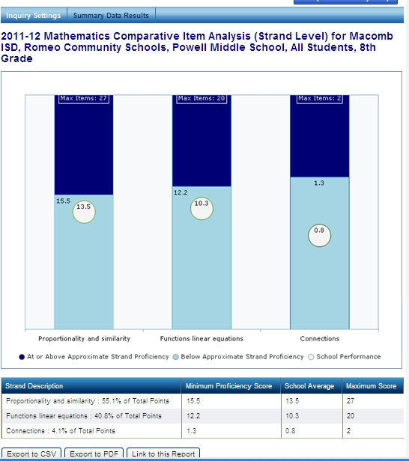
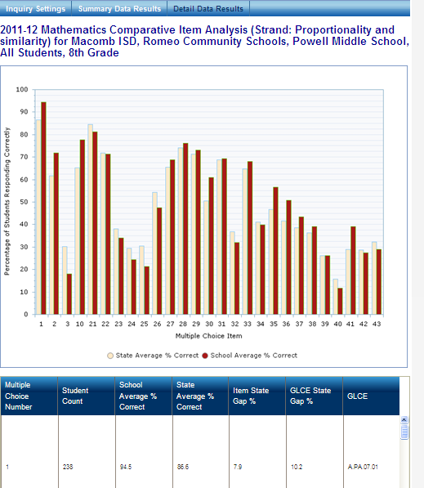
Materials created as part of the Training and Professional Development materials from the MISchoolData portal. Used with permission, 2013.

